

**Tribhuvan University**

**Institute of Science and Technology**

**Himalaya College of Engineering**

A Final Year Proposal Defense Report

On

**“Parking Solution using Automatic License**

**Plate Recognition”**

**Submitted by**

Abin Timilsina [24042/076]

Kritika Sharma [24053/076]

Ruza Kansakar [24067/076]

**Submitted to**

Department of Computer Science and Information Technology

In partial fulfillment of the requirements for the bachelor’s in computer science and information technology

December 2023

# Table of Contents

Table of Contents ii

List of Tables **Error! Bookmark not defined.**

List of Figures iv

Chapter 1: Introduction 1

1.1. Introduction 1

1.2. Problem Definition 2

1.3. Objectives 2

1.4. Limitations 3

1.5. Scope 3

1.6. Report Organization 4

Chapter 2: Literature Review 5

Chapter 3: Requirement Analysis and Feasibility study 8

3.1. Functional and Non- Functional requirements 8

3.1.1. Functional requirements 8

3.1.2. Non-functional requirements 8

3.2. Use Case Diagram 9

3.3. Feasibility Study 10

3.3.1. Economic Feasibility 10

3.3.2. Operational Feasibility 10

3.3.3. Technical Feasibility 10

3.3.4. Project Planning and Scheduling 11

3.4. Structure System Requirements 12

3.4.1. Data Modeling 12

3.4.2. Process Modeling 13

Chapter 4: System Design 14

4.1. Architectural Design 14

4.2. Database Design 15

4.3. Activity Diagram 16

4.4. Algorithm 17

4.5. YOLO Algorithm 17

3.4.3. Working of YOLO Algorithm 17

4.6. CNN Algorithm 18

5.1.1 Working Of CNN Algorithm 18

Chapter 5: Expected Output 19

# List of Figures

Figure 1: Use Case Diagram 9

Figure 2: Gnatt Chart 11

Figure 3: ER Diagram 12

Figure 4: Level-1 Data-Flow Diagram 13

Figure 5: Architectural Diagram 14

Figure 6: Database Diagram 15

Figure 7: Activity Diagram 16

# Chapter 1: Introduction

## Introduction

Automatic Number Plate Recognition (ANPR) technology has surged in popularity in recent years due to its wide range of benefits for various applications like traffic management, intelligent parking, toll automation and surveillance. ANPR is a technique designed to read vehicle number plates without human intervention using high speed image capture with supporting illumination, detection of characters within the images provided, verification of the character sequences as being those from a vehicle numberplate, character recognition to convert image to text; so, ending up with a set of metadata that identifies an image containing a vehicle numberplate and the associated decoded text of that plate.

ANPR was first implemented in 1990s and since then it has come a long way to become more efficient and cost effective. These features have enabled large scale implementation in law enforcements in several countries. However, ANPR still faces some challenges. Vehicle owners have used a variety of techniques in an attempt to evade ANPR systems and road-rule enforcement cameras in general. One method increases the reflective properties of the lettering and makes it more unlikely for the system to locate the plate or produce a high enough level of contrast to be able to read it. There are many difficulties that ANPR systems may face such as poor resolution, poor elimination conditions, blurry inputs, plate occlusion, different font size and variety of plate structures. The image acquisition is quite challenging from vehicles image due to the viewpoint change, when vehicle bodies and license plate have similar color, multi style plate formats and non-uniform outdoor illumination conditions.

In this project, we propose a Parking Solution leveraging Automatic Number Plate Recognition (ANPR) that integrates YOLO for object detection and CNN for Optical Character Recognition (OCR). As a vehicle approaches the entrance, a YOLO-equipped camera captures the license plate in real-time, and the identified region is processed by a CNN for character recognition. The recognized plate information is cross-referenced with a user database for authentication, and if successful, the system allows the driver through. Vehicles with registered plates can automatically enter parking areas while non-registered vehicles will be charged extra by time of check in and check out. Exit process involves automatic plate recognition, billing based on parking duration, and the opening of the exit gate upon payment confirmation. This ANPR solution enhances efficiency, security, and user experience, offering seamless and convenient parking processes. Privacy measures, scalability, and integration with other systems are essential considerations for successful implementation.

## Problem Definition

Traditional parking systems face a great number of challenges that impede their efficiency and user satisfaction. Primarily, reliance on manual ticketing and entry processes results in slow and error-prone operations, leading to long queues, delays, and increased labor costs. Moreover, these systems often lack robust security measures, leaving them vulnerable to unauthorized access and misuse. The absence of efficient authentication measures can contribute to security breaches and instances of unauthorized parking. Manual billing processes are prone to inaccuracies, creating potential disputes and revenue loss for parking facility operators. Additionally, traditional systems may lack user-friendly features, such as mobile app integration or automated payment options, diminishing overall user convenience and satisfaction. Lastly, the environmental impact cannot be overlooked, as inefficient parking systems contribute to increased fuel consumption and emissions due to prolonged wait times, inefficient circulation within parking lots, and congestion around entry and exit points. The integration of modern technologies, as proposed in the solution incorporating ANPR, YOLO, and CNN, aims to address these challenges comprehensively by automating processes, enhancing security measures, and ultimately improving the overall user experience in parking facilities.

## Objectives

1. To implement an automated entry and exit system using YOLO-equipped cameras for automatic plate recognition, eliminating the need for manual ticketing, and streamlining the entry and exit process for vehicles in the parking facility.
2. To implement a time-based charging mechanism for registered vehicles during check-in and check-out and charge extra for non-registered vehicles.
3. To enhance user experience by reducing wait times and integrating user-friendly features such as mobile/web app access and automated payment options for seamless transactions.

## **Limitations**

While the proposed parking management system addresses many challenges in traditional parking systems, it also has certain limitations. Some of the potential limitations include:

1. Cost of Implementation: Integrating advanced technologies such as ANPR, YOLO, and CNN may involve significant upfront costs for hardware, software, and system integration. This could be a barrier for smaller parking facilities with limited budgets.
2. Limited Recognition Accuracy: While YOLO and CNN technologies are advanced, there may still be limitations in the recognition accuracy, especially under challenging conditions such as poor lighting, adverse weather, or obscured license plates.
3. Privacy Concerns: The use of ANPR raises concerns about privacy, as the system involves capturing and processing vehicle license plate information. Ensuring compliance with privacy regulations and addressing public concerns about data security is essential.
4. Limited Coverage for Non-Standard Vehicles: The system may have limitations in recognizing license plates for non-standard vehicles, such as motorcycles or vehicles with unconventional plate placements, potentially excluding certain categories of users.

## Scope

1. Entrance Process: Real-time capture of license plate using YOLO-equipped camera as a vehicle approaches the entrance. Processing of the identified license plate region using CNN for character recognition.
2. Authentication and Access Control: Cross-referencing the recognized plate information with a user database for authentication. Granting access to registered vehicles and allowing them to enter parking areas seamlessly. Charging non-registered vehicles based on parking duration during check-in and check-out.
3. User Database Management: Maintenance and management of a user database containing registered vehicle information. Regular updates to accommodate new registrations and changes in existing user details.
4. Exit Process: Automatic plate recognition at the exit for registered vehicles. Billing based on parking duration for both registered and non-registered vehicles. Opening of the exit gate upon payment confirmation.

## Report Organization

* Chapter 1 introduces the rising significance of Automatic Number Plate Recognition (ANPR) technology and proposes an advanced Parking Solution integrating YOLO and CNN to address challenges in traditional parking systems, aiming to enhance efficiency, security, and user experience while acknowledging potential limitations and outlining specific objectives and scope.
* Chapter 2 reviews existing literature on ANPR systems, highlighting diverse approaches such as deep learning models, machine learning techniques, and surveys. Studies showcase methods like CNN-based plate recognition with high accuracy, cost-efficient systems utilizing infrared cameras, and comprehensive surveys evaluating ANPR methodologies.
* Chapter 3 outlines the requirements for the proposed ANPR-based parking solution, encompassing functional and non-functional aspects.
* Chapter 4 gives information about architectural design and algorithms.
* Chapter 5 includes expected output.

# Chapter 2: Literature Review



Several studies and work have been carried out earlier. In [1-2], a deep learning model is created to recognize the number plate using the Turkish dataset made by them. They used TensorFlow framework with the Keras deep learning library. They collected 34, 58 images of which the smearing algorithm is applied using a MATLAB program. 75% of the images were used for training, 25% for testing and 5% for validation. Since the images were taken from the real time background, they carried out several image processing techniques like median blur smoothening, Adaptive Gaussian thresholding and morphological transformations. After these preparations, the CNN model is trained using the images. The image features extracted from CNN are applied to LSTM network followed by the decryption algorithm. By this method, they achieved an overall accuracy of 96.36% for plates, 99.43% for numbers, 99.05% for letters 99.31% for all the characters.

In [3], an automatic number plate recognition system using machine learning approach is developed. They got the input from an Infrared camera followed by contrast enhancement and noise reduction as preprocessing steps. Then they localized the number plate in the image by finding out the Region of Interest (ROI). After that, contour tracing is applied to get the salient features of the image. Then Canny's edge detection is done to find out the edges of the characters in the number plate. Finally, segmentation is applied to separate the characters. The individual characters are recognized using pattern matching by Artificial Neural Networks (ANN). The whole system was developed using MATLAB software. The author describes this system as a cost efficient and accurate system.

A survey was carried out [4] on various methodologies used in implementing Automatic Number Plate Recognition (ANPR). The authors took nearly 78 reference papers and evaluated their accuracy results. The basic steps in ANPR include vehicle Image capture, number plate detection, Character segmentation and Character recognition. For number plate detection the factors such as plate size, plate location, plate background and screw must be considered. The maximum accuracy for plate detection was achieved by Canny's edge detection as per the survey. Character segmentation can be implemented using image binarization, CCA (Connected Component Analysis), vertical and horizontal projection which produces better results. It is followed by character recognition which is usually done by Artificial Neural Networks, template matching or Optical Character Recognition (OCR) techniques. The maximum accuracy for Character recognition was achieved by tesseract OCR with 98.7% results.

In [5], a review based on Automatic Number Plate Recognition (ANPR) is carried out. The proposed system consists of a camera module, sensor, control unit, GSM, and an embedded server. It tries to block the unauthorized vehicles by comparing the vehicle database saved already. The images captured from the camera are converted to gray scale and enhanced by adjusting the histogram. The edges are detected using Sobel's edge detection method. Then morphological image processing is done. After that, the segmentation is done on the edge detected image. Finally, the characters are recognized using machine learning approach.

In [6], a plate recognition system using deep learning approach is developed. They developed an OCR system with a customized dataset. The dataset was made artificially by taking some images from the internet and adding noises and backgrounds to those images. For background, SUN database and Standford database are used. For number plate detection YOLO (You Only Look Once), an object detection framework is used. For character recognition, Convolutional Neural Network (CNN) is used. The output layer of the CNN consists of 7.62 neurons for 7 characters. 10-fold-cross validation is applied at the output to find the accuracy. The overall accuracy for the CNN plate detector is 98.5% and for the CNN character recognition is 96.8%. This OCR based system gives an overall system efficiency of 94%.

In [7], a number plate recognition system is created using Convolutional Neural Network. The images taken from a camera is preprocessed by converting the RGB image to gray scale, noise removal and binarization. Then the license plate is extracted by using Connected Component method depending upon the properties such as major axis length, minor axis length, area and bounding box etc., The characters in the extracted license plate is segmented using horizontal and vertical scanning. Finally, The characters are recognized using Convolutional neural network (CNN). The dataset used to train the CNN consists of 1000 images for each 36 characters. Out of 36,000 images, 30,000 samples are used as training data and 6000 for testing data. They used descent algorithm to minimize cross-entropy with a learning rate of 0.5. The overall accuracy obtained was 97%.

# Chapter 3: Requirement Analysis and Feasibility study



## Functional and Non- Functional requirements



### Functional requirements

* The camera should accurately detect vehicles approaching the entrance and capture the license plate in real time.
* The Convolution Neural Networks (CNN) should process the identified license plate region for character recognition and the OCR system must accurately extract and interpret the characters on license plate.
* The recognized plate information should be cross reference with the user database for authentication.
* Nonregistered vehicles should be charged extra based on the duration of parking calculated from checking to check out times.
* Billings should be performed based on the parking duration of vehicles.
* The exit gates should open after payment confirmation.

### Non-functional requirements

* The system should operate in real time providing quick and accurate result for vehicle detection plate recognition and authentication.
* Implement robust security measures to protect the user database and prevent unauthorized access.
* Provide a seamless and user-friendly experience for both registered and non-registered users to use the parking system.

## Use Case Diagram

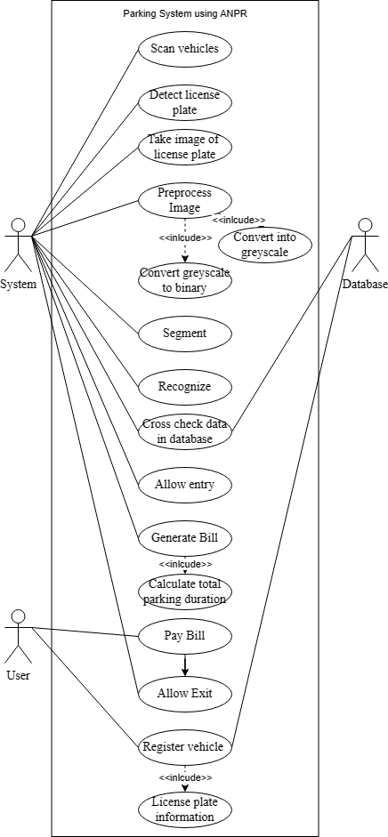

**Figure 1: Use Case Diagram**

The diagram illustrates an automated parking system that utilizes ANPR technology to streamline vehicle entry, exit, and payment processes.

## Feasibility Study



### Economic Feasibility

* Evaluate the initial and ongoing costs of implementing the ANPR parking solution against the anticipated benefits.
* Calculate the expected Return on Investment (ROI) over a specified period, considering factors like reduced manpower requirements, increased revenue from non-registered vehicles, and potential scalability benefits.
* Perform a cost-benefit analysis to assess the project's financial viability.

### Operational Feasibility

* Identify the training needs for staff operating and maintaining the system.
* Evaluate the system's ability to scale with the growth in the number of users and vehicles.
* Assess the feasibility of maintaining and supporting the system over time.

### Technical Feasibility

* Evaluate the availability and compatibility of the required technologies (YOLO for object detection, CNN for OCR) and ensure they meet the system's performance and accuracy requirements.
* Ensure compatibility and feasibility of integrating the ANPR solution with existing parking management systems, databases, and other relevant technologies.
* Ensure that the system adheres to legal and regulatory requirements related to data privacy, security, and any other relevant standards in the implementation region.

### Project Planning and Scheduling

The work breakdown and time in week as well as days required to complete the project is shown below:

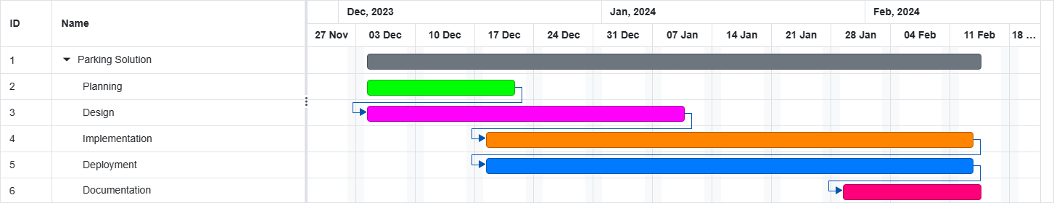

**Figure 2: Gnatt Chart**

This diagram shows the timeline of our planned project including design, implementation, deployment, and documentation.

## Structure System Requirements



### Data Modeling

#### ER Diagram

**Figure 3: ER Diagram**

This diagram show the relationship between different entities like user, database and the system and how they are associated with each other.

### Process Modeling

#### Data flow Diagram (DFD)

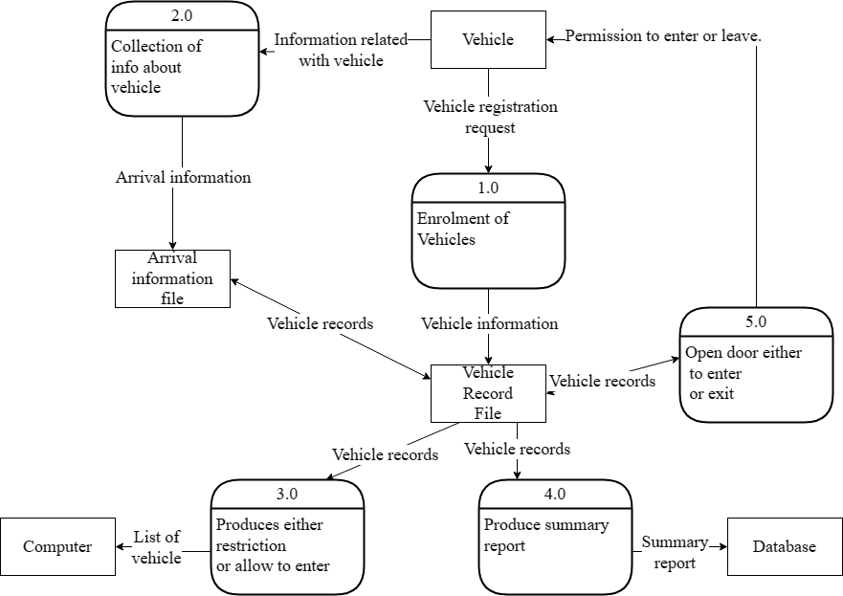

**Figure 4: Level-1 Data-Flow Diagram**

This diagram shows the process of collecting information about vehicles, to determine whether to grant permission to enter or leave. The process starts with collecting arrival information, which is then used to enroll the vehicle and create a vehicle record. The vehicle record is then used to check for restrictions and produce a summary report.

# Chapter 4: System Design

1. 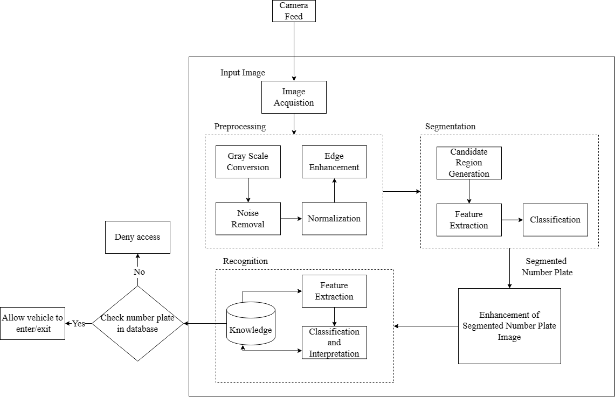

## Architectural Design

**Figure 5: Architectural Diagram**

This diagram shows the overall system architecture starting from image feed to allowing /denying vehicle entry in parking facility.

## Database Design

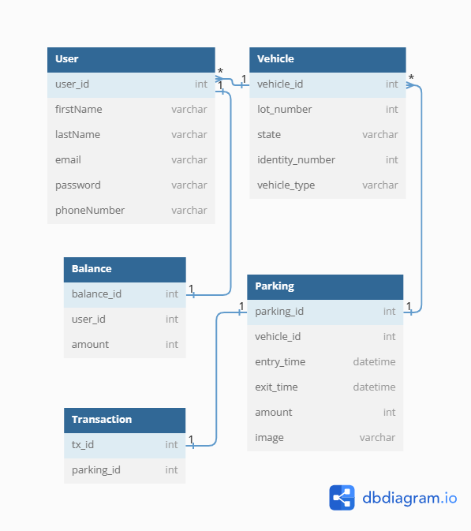

**Figure 6: Database Diagram**

The schema defines five tables: User, Vehicle, Parking, Balance, and Transaction. These tables are linked together by foreign key relationships.

## Activity Diagram

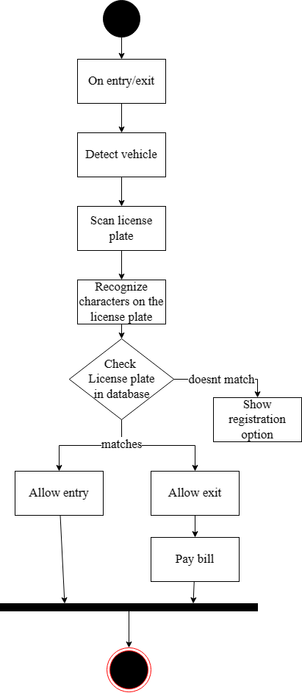

**Figure 7: Activity Diagram**

This diagram shows the activities that the system performs when a license plate is detected by the YOLO equipped camera in the parking facility.

## Algorithm



### YOLO Algorithm

YOLO, which stands for "You Only Look Once," is a popular object detection algorithm in computer vision and deep learning. The primary advantage of YOLO is its ability to perform real-time object detection with high accuracy. This object detection is done as a regression problem.

It is used to predict various classes and bounding boxes simultaneously. Most of the license plate have different background and foreground color. Need to train the model with YOLO custom weights to successfully complete the localization of the license plate. The recognition and localization of vehicle license plates is a critical task for an ALPR system.



##### **Working of YOLO Algorithm**

In the YOLO algorithm, the input image is divided into an n x n grid, and each grid cell is responsible for predicting multiple bounding boxes (typically 5). This means that the total number of bounding boxes predicted by the algorithm is n x n x 5.

Each bounding box prediction includes the coordinates of the box's center (x, y), width (w), height (h), and a confidence score. It gives a confidence score which shows how confident the algorithm is that the object to detect exists in the bounding box. The score doesn't tell the type of object but tells the confidence score if it is in that bounding box or not.

For example, there are 13*13 grid cells, and each cell detects 5 bounding boxes so total bounding boxes becomes 13*13*5 which makes 845 bounding boxes. Now the beauty of the algorithm is that these total 845 boxes were predicted all at once as the name suggests “You Only Look Once”.

The simultaneous prediction of all bounding boxes in a single pass through the network is a key characteristic of YOLO, and it contributes to the algorithm's efficiency and real-time processing capabilities. This contrasts with some other object detection approaches that involve multiple stages or steps in the detection process.

### CNN Algorithm

A convolutional neural network (CNN) is a type of machine learning in which a model learns to perform classification for applications that call for object detection and computer vision. CNN eliminates the need for manual feature extraction since the features are directly learned by the network. CNNs can be retrained for new tasks that can build on pre-existing networks.

Convolutional Neural Networks (CNNs) are widely used in Optical Character Recognition (OCR) tasks due to their ability to automatically learn hierarchical features from input data. OCR involves recognizing and interpreting characters in images, scanned documents, or handwritten text.

##### **Working Of CNN Algorithm**

In character recognition using Convolutional Neural Networks (CNNs), the network processes input images through convolutional and pooling layers to automatically learn and extract relevant features such as edges and textures. These features are then flattened and fed into fully connected layers, which learn to recognize patterns and associations. The final layer uses a SoftMax activation to output probabilities for each possible character, and during training, the network adjusts its parameters to minimize the difference between predicted and true labels. Once trained, the CNN can accurately recognize characters in new images through a process of forward propagation, making it a powerful tool for tasks like reading printed or handwritten text.

# Chapter 5: Expected Output

The envisioned outcome is a fully automated parking solution designed to simplify the vehicle parking process, enabling users to effortlessly park their vehicles and settle generated bills based on their parking duration, all without the need for human involvement. The system is expected to seamlessly identify incoming vehicle number plates as they enter the parking facility, utilizing Automatic License Plate Recognition (ANPR) technology. This involves the real-time capture of license plate information, which is then cross-referenced with a database to grant authorization. Additionally, the system is capable of deducting parking fees directly from the user's account, the amount being determined by the duration of their parking stay. The overall goal is to create a user-friendly and efficient parking experience, eliminating manual interventions and streamlining the entire process from entry to payment.



# References

1. I. Kilic and G. Aydin, "Turkish Vehicle License Plate Recognition Using Deep Learning," 2018 International Conference on Artificial Intelligence and Data Processing (IDAP), Malatya, Turkey, 2018, pp. 1-5, doi: 10.1109/IDAP.2018.8620744.
2. J. V. Bagade, Sukanya Kamble, Kushal Pardeshi, Bhushan Punjabi, Rajpratap Singh, "Automatic Number Plate Recognition System: Machine Learning Approach," IOSR Journal of Computer Engineering (IOSR-JCE).
3. A. Patel, C. Patel, and D. Shah, "Automatic Number Plate Recognition System (ANPR): A Survey," International Journal of Computer Applications, vol. 69, no. 9, pp. 0975–8887, 2013.
4. Shraddha S Ghadage, Sagar R Khedkar, "A Review Paper on Automatic Number Plate Recognition System using Machine Learning Algorithms," International Journal of Engineering Research & Technology (IJERT), vol. 8, issue 12.
5. Marko Arsenovic, Srđan Sladojevic, Andras Anderla, Darko Stefanovic, "Deep Learning Driven Plates Recognition System," XVII International Scientific Conference on Industrial Systems, Novi Sad, Serbia, 2017.
6. Shrutika Saunshi, Vishal Sahani, Juhi Patil, Abhishek Yadav, Dr. Sheetal Rathi, "License Plate Recognition Using Convolutional Neural Network," IOSR Journal of Computer Engineering (IOSR JCE), e-ISSN: 2278-0661, p-ISSN: 2278-8727.
7. Selmi Zied, Ben Halima Mohamed, Alimi Adel, "Deep Learning System for Automatic License Plate Detection and Recognition," 14th IAPR International Conference on Document Analysis and Recognition (ICDAR), pp. 1132-1138, 2017.